Source Control

Merging

Fast Forward Merge
- We have a main branch
- We created a feature branch from the main branch
- We change stuff in the feature branch
- No changes in the main branch during this time
- We merge feature with main
- This merge is simple and is called as Fast Forward merge where the main branch now just points to the latest commit of the feature branch
- No separate commit for the merge. Just move the head to the latest version
- Use git log –graph to see a visual on commits

Different Merging (ORT)
- We have a main branch
- We created a feature branch from the main branch
- We change stuff in the feature branch
- We change stuff in the main branch as well
- We merge feature with main
- This merge follows ORT strategy to merge two branches that have their own changes
- A separate commit for the merge.
- Use git log –graph to see a visual on commits

Squash Merge
If you don’t want all the commits from feature branches to come to main branch, use squash merge.
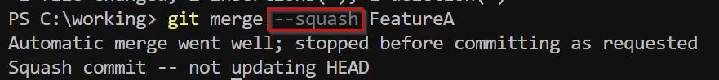

Tags
It can be used to specify which commit is important in the repository
You can mark release points with the use of tags

Lightweight Tag
Just a pointer to a specific commit

Annotated Tag
Stored as full objects in Git database. They are checksummed, contain tagger name, email, data and a message
